**Process Flow - US Visa - All (B1/B2, L1, H1B)**

**Step 1: Complete DS 160**

* Go to US Embassy website - [www.ustraveldocs.com/in](http://www.ustraveldocs.com/in)
* **Click on “Complete My DS160”.**

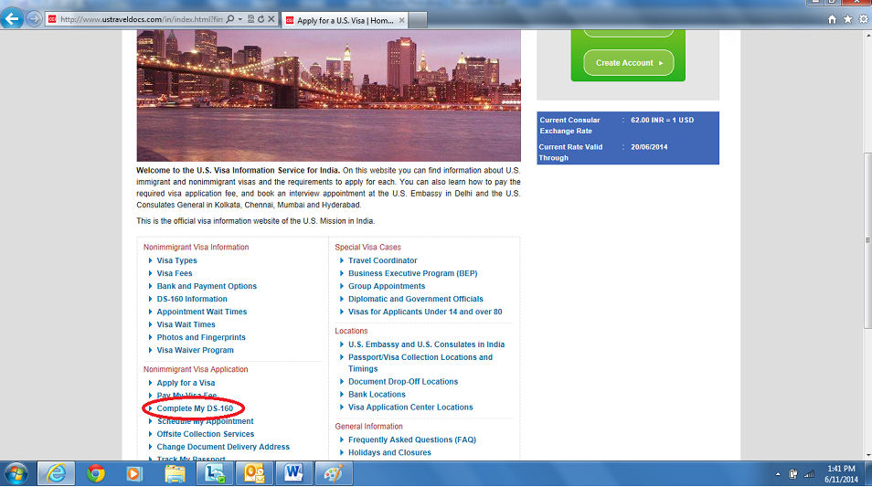

* **Click on “The Form DS-160 is online here”.**

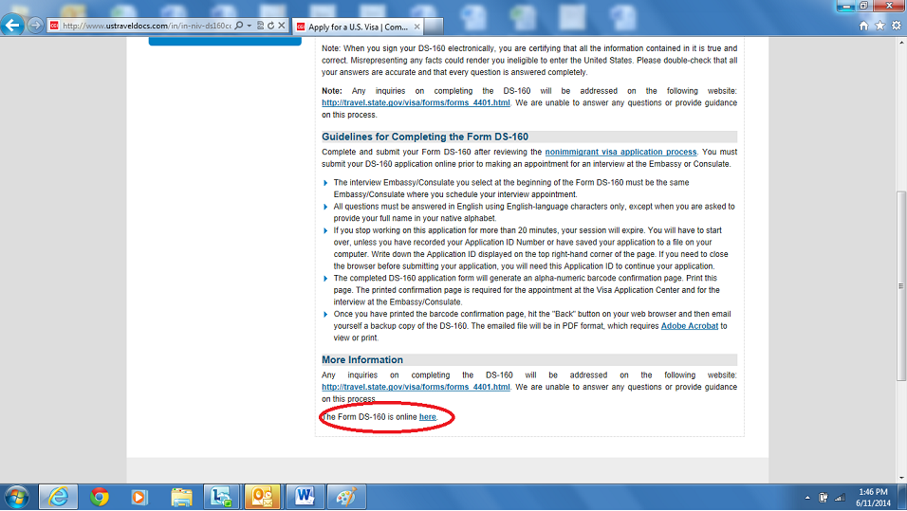

* **Start filling DS-160 form online** (Refer sample form in Annexures)
* **Select correct visa category as the case may be - B1/B2, L1, H1B, L2, H4**
* **Complete the form and save application. Share screenshots of all pages with Immigration desk for review prior to submission.**
* **Submit DS160 and print confirmation page**
* **If you require completing DS160 for dependants(spouse + child) too, click “Family Visa” after your DS 160 has been submitted.**

**Step 2: Complete Individual Profile**

* Go to [www.ustraveldocs.com/in](http://www.ustraveldocs.com/in)
* Click on “Create Account”, provide a login id and password required to create an account. Save these credentials for future logins.

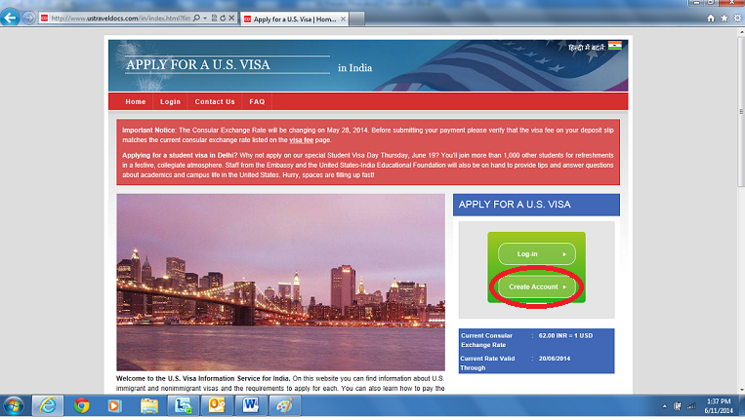

* **“New User Registration window opens”, start filling all the details to create the login.**

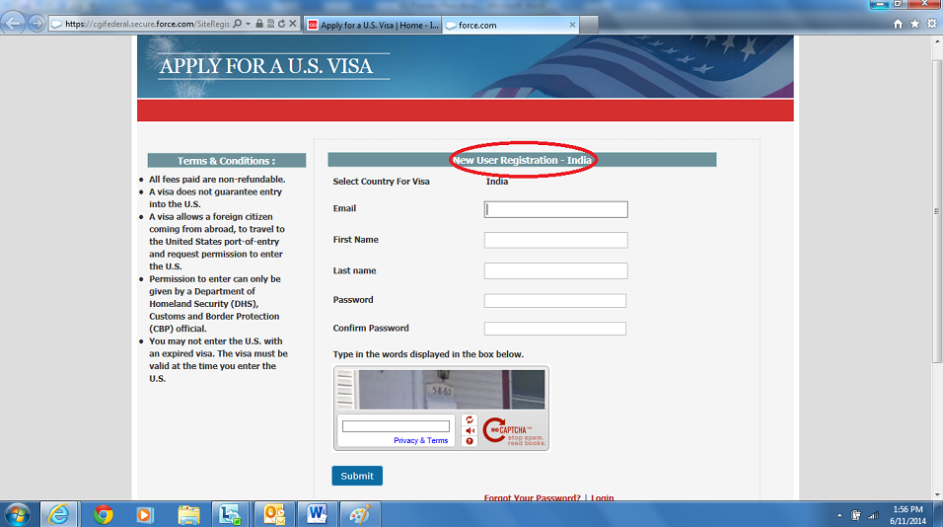

**Step 3: Visa Fee payment**

Create the profile and once you reach Step 8: “Please enter your MRV receipt information below” -

* **Click on: “Click here for all payment options”.**

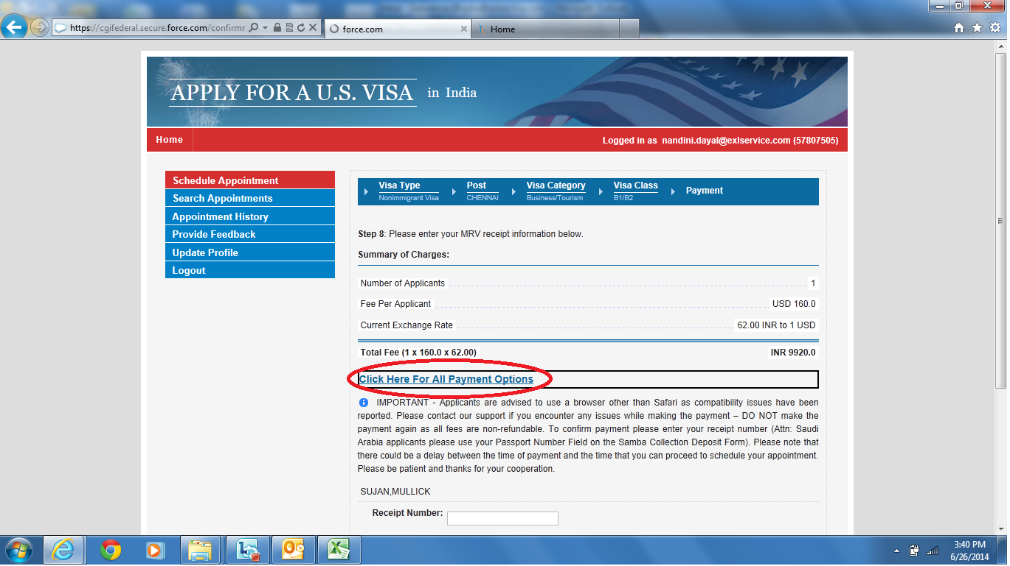

* **There are two modes of payment.**

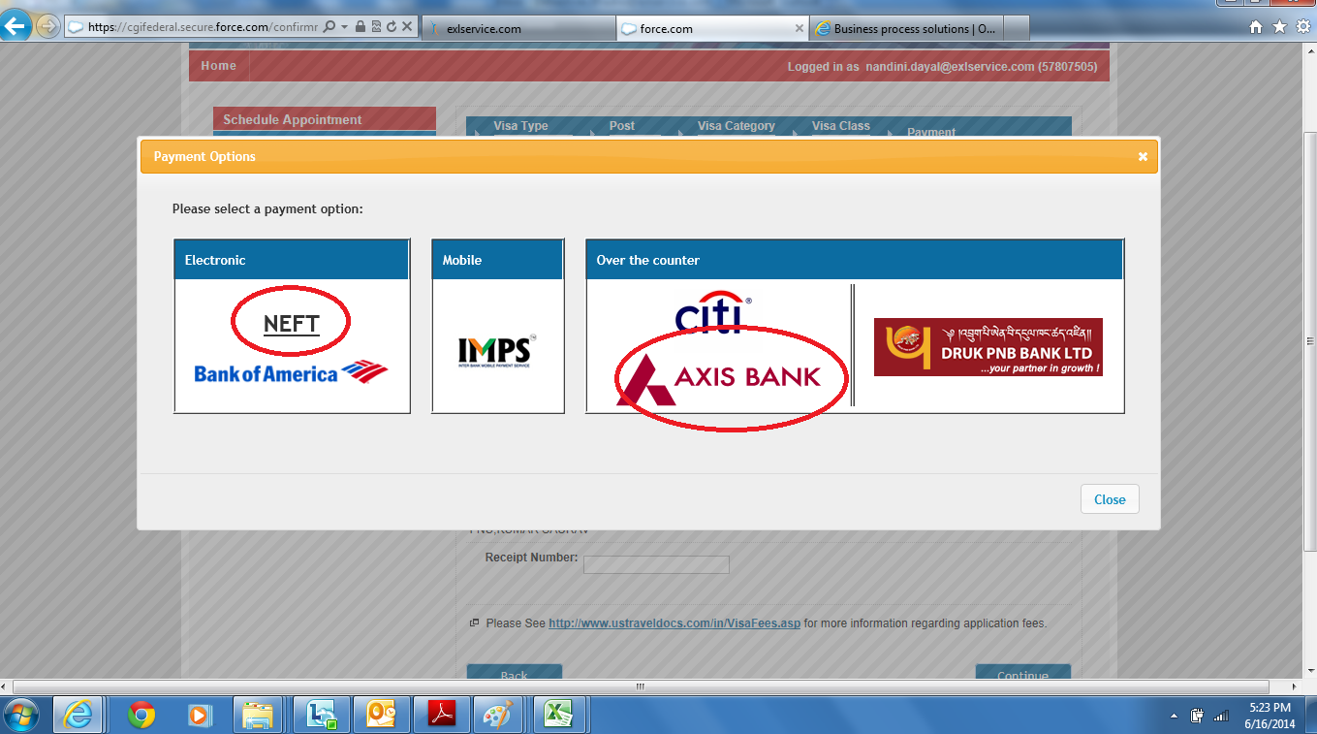

1. **NEFT:** Opt for NEFT to execute online transfer of fee amount from your personal bank account. On the payment confirmation screen, you will receive a unique beneficiary account number to which you will send the NEFT payment. You must save this unique account number that you actually use to make your NEFT payment. You must have this number as proof of payment in order to schedule your visa interview appointment.

**Maximum transaction value allowed per day(24 hours) in INR 50,000 only. So in case you have 4 or more applicants and total visa fee exceeds INR 50,000, you will have to make two separate transactions on two days.**

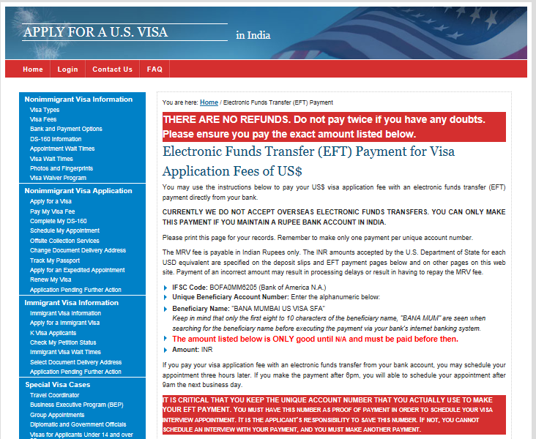**(b)** **AXIS bank for cash payment:** Payment can be made at any AXIS bank branch in India. Click on the AXIS bank icon to be directed to the cash payment gateway. Print the *cash payment slip* and carry it to the bank along with *cash* and *passport (original)*

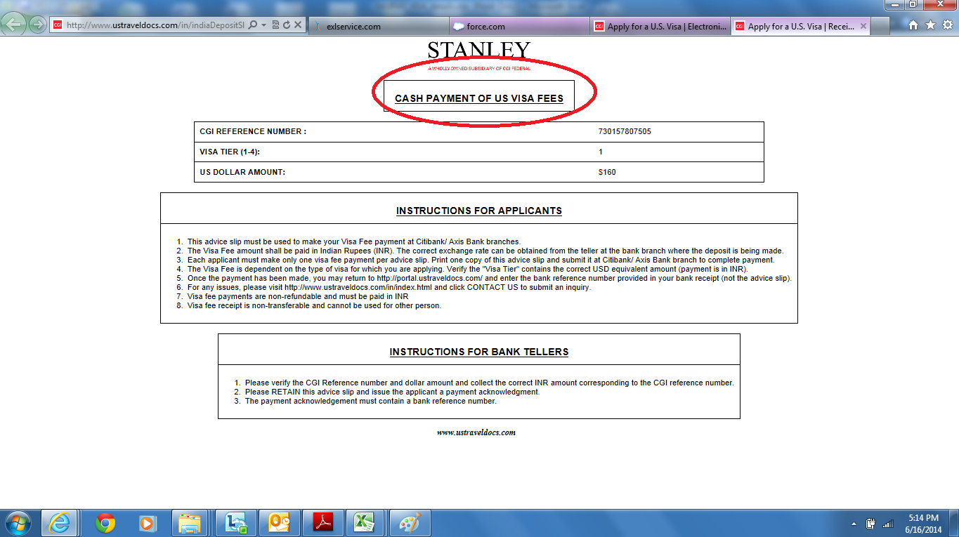

After making fee payment, the employee will receive an email from the US Embassy confirming that the mentioned visa fee receipt has been activated. This can take 1-3 hours after having made the payment. Please make a note of the visa fee receipt number that is mentioned in the email.

*Note: The fee is non-transferable and non-refundable and can be used for a period of up to 1 year from the date of fee remittance. Please ensure that no errors are made while executing the fund transfer. The Unique Reference Id issued to you should be made note of.*

***IMP: An additional fee of $500(INR 34000 at current exchange rate) is to be paid by L1 Blanket Principal applicants only, at the US Consulate in Chennai at the time of visa interview. L2 applicants do not pay this fee. This may be paid via credit card (AMEX corp card/ personal card) or via demand draft.***

***Demand draft details:***

**Amount:** INR 34,000 (Rupees thirty four thousand only))

**Addressed to:** Consulate General of the United States

**Payable at:** Chennai

**Step 4: Schedule appointment**

**Two appointments** to be scheduled:

1. **Biometrics/OFC @ VFS office**: For digital photo and fingerprinting process
2. **Interview @ US Embassy:** Face to face interview with Visa counsellor

**Important**:

**L1 Blanket** applicants must attend the interview at **US Embassy, Chennai** only.

**Biometric appointment may be scheduled at ANY consular post (New Delhi/ Chennai/ Kolkata/ Mumbai)**.

It is possible to schedule the appointment for Biometrics in Chennai on the same day as the Consular appointment (Consular appointment must be on/after 11 am); this is subject to availability of appointment slots. Schedule

While scheduling the appointments, the first screen that shows up will be for the Consular appointment (for L1 Blankets - default location is Chennai). After scheduling the Consular appointment, next screen will show **OFC/Biometric** appointment calendar. By default, the location will be pre-selected as Chennai – **please change to your desired location before scheduling the appointment.**

**L2** **Blanket** applicants need not travel to Chennai; they can schedule appointments at any consular post in India. Children below the age of 14 years do not require attending neither Biometric nor Consular appointment. Parent can carry their documents to the Embassy/ Consulate and submit at the time of interview

To schedule the appointment follow the below steps.

* Go to [www.ustraveldocs.com/in](http://www.ustraveldocs.com/in)
* Login in using your login id and password
* Click on “Schedule Appointment” and proceed to schedule your appointment
* While scheduling appointment, please keep handy the fee receipt number, UID & L1/ H1B petition details
* Print Appointment confirmation page

**Once appointment has been scheduled, the appointment confirmation page must be shared with Immigration Desk. Please keep a copy of this page for future reference.**

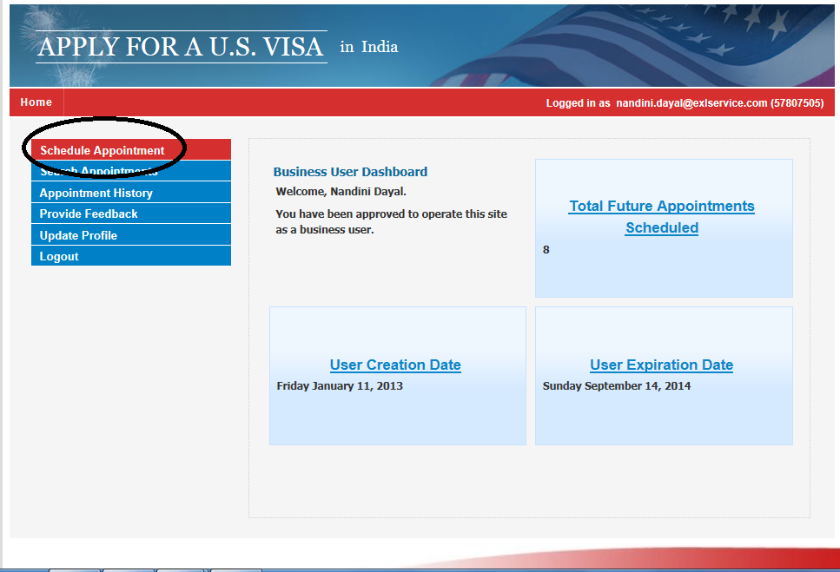

**Step 5: Briefing Session with Immigration Desk**

**It is mandatory for all applicants to attend a briefing session**. On sharing the appointment confirmation, Immigration desk will set up a briefing session at least 2-3 days prior to visa appointment date.

For B1/ B2 visa, Immigration desk can arrange EXL Invite letter, in case client invite is not available. **Applicant must carry a day to day travel agenda along with the Invite letter to the Embassy for the interview.**

In case of L1or H1B, Immigration desk will hand over the petition documents to the employee at the time of briefing. In case of outstation applicants, please share your residential address for courier of L1 package.

**FAQ’s/ Important points to be noted:**

1. **In case of Business visa - please proceed with the visa application process only after Immigration Desk approves the request.**
2. The data entered in the form should be accurate and true in all respects.
3. **The VISA appointment can be re-scheduled up to 3 times. If you try more than 3 times the fee receipt will be deactivated and you have to pay the VISA fee again.**
4. **While checking for available appointment dates, please keep a gap of 2-3 hours between every log in as too many frequent log in to the system will lock your account.**
5. The Given name and Surname on the DS160 & Profile should be as per the passport. In case if there is no surname mentioned in the passport then put “FNU” as Given name and Given Name in passport as the Surname. Please ensure the name is mentioned in the same format on both DS 160 and the profile.

Eg. If on passport- GIVEN NAME is SUDHIR KUMAR and SURNAME is blank,

GIVEN NAME = FNU and SURNAME= SUDHIR KUMAR

1. On the Page 3 of DS160, under Work/Education/Training information - **‘’Monthly Salary in Local Currency’’** ensure you mention your monthly salary ie. Gross CTC / 12**. IN case of L1 - “Monthly salary in USD” must also be the USD salary on I129S/ 12.**
2. Passport number must read as “J123456”, no space between the alphabet and number.
3. Dress Code for Embassy appointment: Business Formal, no jeans.

# Annexures

1. **Sample B1/B2 DS160 form**



1. **Sample L1 DS 160_ Imp pages.**



1. **Document Checklist**



# 